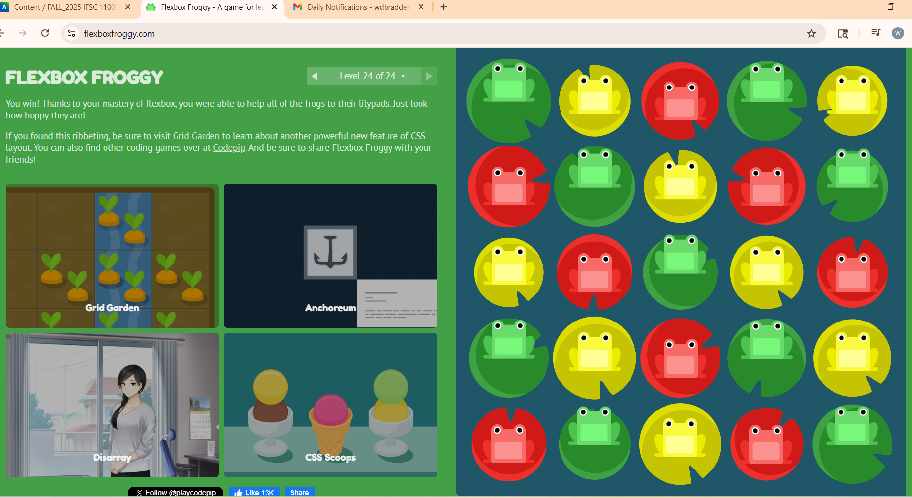

https://flexboxfroggy.com/

